Java Portfolio for my project “GCD”.

Date: May 22, 2023

What is it: I wrote a program that’s really helpful on math, it comes handy whenever I need to find the greatest common divisor of two numbers.

Source code: gcd.java

import java.util.Scanner;

public class gcd{

public static void main(String[]args){

Scanner inp= new Scanner(System.in);

while(true){

int gcd=1, i=1;

System.out.println("Type in two integers to find their greatest common divisor: ");

int n1=inp.nextInt();

int n2=inp.nextInt();

do{

if(n1%i==0 && n2%i==0)

gcd=i;

i++;

}while(i<=n1 && i<=n2);

System.out.println("GCD of "+n1+" and "+n2+" is "+ gcd+".");

}

}//main

}//class

How it goes:

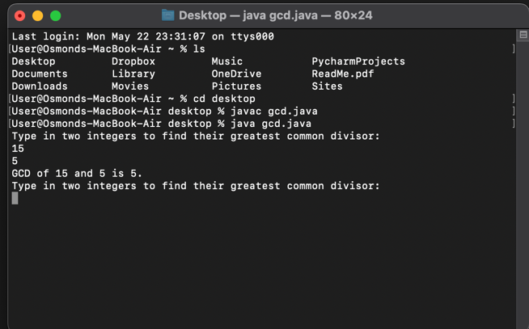

What I have learned:

1. Knowing how to find GCD using Java in three different loops, including for loop, do while, and while loop.
2. Being aware of the difference between three different types of loops and the application of infinite loops.